

SHENZHEN SNS TECHNOLOGY CO., LTD

PRODUCT SPECIFICATION

ITEM ： SNS-NDOOR FULL COLOR-P4(1M SPHERE )

DATE ： 2019-8-12

NO. ： 20190812A

|  |  |  |  |
| --- | --- | --- | --- |
| Confirm | Approved | Audit | Writing |
| Signature |  |  |  |
| Date |  |  |  |

**1、Display Specification：**

P4(SMD2121)Actual Pixel

|  |  |  |  |  |  |  |  |  |
| --- | --- | --- | --- | --- | --- | --- | --- | --- |
| **Product** | **Item** | **Tech Specification** | | | | | | |
| **Module** | **LED** | Pixel Commposition1R1G1B |  | Wave Length | | Brightness | | SMD or DIP |
| RED | 620～625nm | | 150～180mcd | | SMD2121 |
| GREEN | 522～525nm | | 300～350mcd | |
| BLUE | 468～470nm | | 80～110 mcd | |
| **Pixel Pitch** | 4mm | | | Temperature | | Storage：-40℃ ～ +85℃  Working：-10℃ ～ +50℃ | |
| Pixel composition | 1R1G1B | | | Humidity | | ≤10～95% | |
| Physical density | 62500 pixels/㎡ | | | Brightness | | ≥1000cd/㎡ | |
| Unit Module size | 64mm×256mm | | | Brightness Adjustment | | Software 256 scale or automatic adjustment | |
| Module resolution | W 16×H 64点 | | | Refresh rate | | ≥1920HZ | |
| Best view angel | H：120°，V：120° | | | Frame rate | | ≥60Hz | |
| Best view distance | ≥4m | | | Input power | | AC 110V/220V | |
| Unit Module structure | Light drive together | | | Average power consumption | | 400W/㎡ | |
| Drive mode | Constant driving,1/16 Scan | | | Maximum power consumption / ㎡ | | 800W/㎡ | |
| Drive IC | MBI5124 | | | Continuous working trouble-free time | | 1000 hours | |
| Module weight | 0.1kg | | | Working life | | 100，000 hours | |
| Control System | Control System | | | | LINSN / NOVA | | | |
| Control method | | | | [synchronization](http://www.so.com/link?url=http://dict.youdao.com/search?q=%5b%E7%89%A9%5d%20synchronization&keyfrom=hao360&q=%E5%90%8C%E6%AD%A5+%E8%8B%B1%E6%96%87&ts=1506051403&t=6fe04bf62f37b37dbf378748e170af3" \t "https://www.so.com/_blank) Control | | | |
| **Cabinet** | Diameter | | | | 1000mm | | | |
| Standard Cabinet weight | | | | 80Kg | | | |
| Environment Temperature | | | | Storage：-40℃ ～ +85℃ | | | |
| Working：-10℃ ～ +50℃ | | | |
| **Standard configuration** | Unit module and unit module power cable | | | | 1.5 red/black GB standard L=110mm | | | |
| Unit module and unit module data cable | | | | 16P data cable L=180mm | | | |
| module and cabinet screws | | | | M1.4×6Nickel-plated round head screw  (Including flat pad pad) | | | |

1. 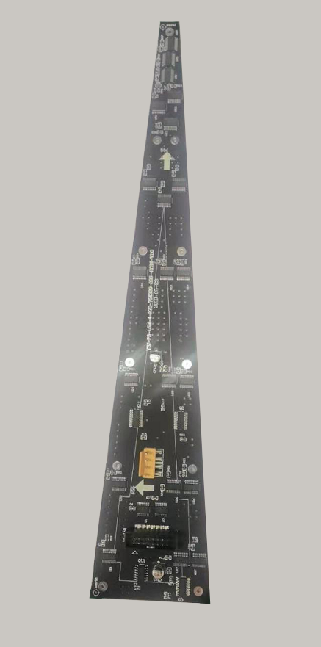**Module picture**

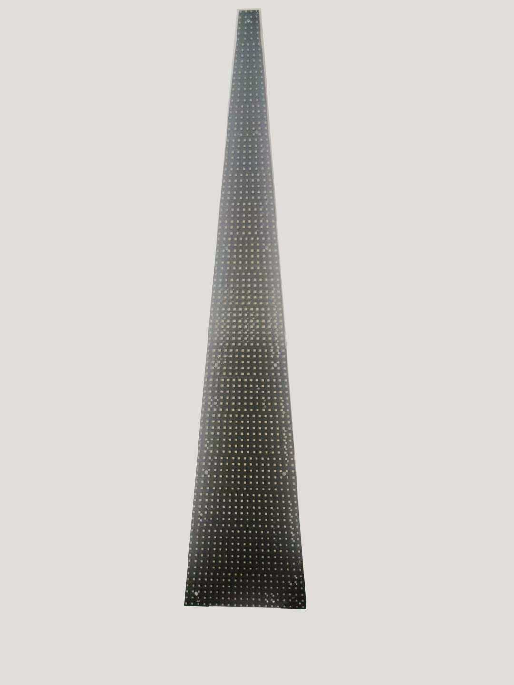

1. **Screen diameter（$±0.2mm)$:**

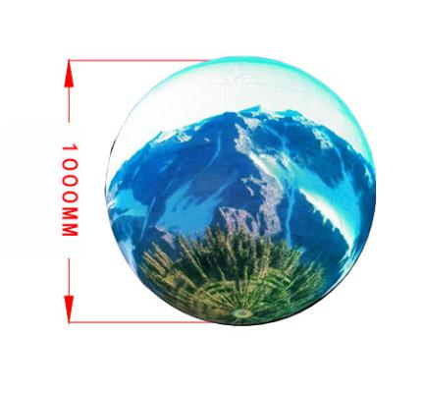

1. **Product Features Description:**

Using 4mm point spacing, display images delicate and realistic, uniformity, brightness, good viewing angle, with high brightness, visual distance, to ensure that the business area of the area can be clearly visible to the display.  
 High reliability, wide applicability, high brightness, cost-effective. To meet your high-quality display of the pursuit of the screen also has a good price, greatly reducing your investment costs.

1. **Applications:**

Indoor advertising media, corporate propaganda, conference hall, enterprises and institutions public square announcement.

1. **Module Connection Definition：**

|  |  |  |  |  |  |  |
| --- | --- | --- | --- | --- | --- | --- |
| Feet | Signal | Feet | Signa | Connection Specification | | Signal foot arrangementarrangementarrangement |
| 1 | RD1 | 2 | GD1 | Rx-Red data  R2  红色数据 | OE- Control Signal  控制信号 | HUB75 |
| 3 | UD1 | 4 | N | Gx-Green DataG2  绿色数据 | GND  电源地 |
| 5 | RD2 | 6 | GD2 | Ux-Blue Data  B2  蓝色数据 | NC - Empty Feet |
| 7 | UD2 | 8 | N | A -Address Signal  A地址信号 |
| 9 | A | 10 | B | B -Address Signal  B地址信号 |
| 11 | C | 12 | N | C -Address Signal  C地址信号 |
| 13 | S | 14 | LAT | CLK -Clock Signal  时钟信号 |
| 15 | O | 16 | N | STB-Data latch signal  数据锁存信号 |

|  |  |  |  |  |  |  |  |  |  |  |  |  |  |  |
| --- | --- | --- | --- | --- | --- | --- | --- | --- | --- | --- | --- | --- | --- | --- |
| 1. **Cabinet Standard Spare Parts：** | | | | | | | | | | | | | | |
| Cabinets Spare Parts | | ＜50 | 50-200 | 200-500 | | 500-1000 | | 1000-2000 | | 2000-5000 | | ＞5000 | | |
| LED（Set） | | 5 | 10 | 20 | | 40 | | 50 | | 100 | | 100 | | |
| Constant current IC | | 2 | 5 | 10 | | 15 | | 20 | | 30 | | 30 | | |
| Other IC | |  | 4 | 4 | | 4 | | 10 | | 10 | | 20 | | |
| Module Signal Data（Line） | | 3 | 5 | 10 | | 15 | | 30 | | 30 | | 30 | | |
| Cabinet Signal Data（Line） | | 3 | 5 | 5 | | 10 | | 20 | | 30 | | 30 | | |
| System Signal Data（Line） | | 2 | 5 | 5 | | 10 | | 20 | | 30 | | 30 | | |
| The specific need to combine the actual situation and customer requirements! | | | | | | | | | | | | | | |
| Shenzhen SNS Technology Co., LTD Standard Spare Parts | | | | | | | | | | | | | | |
| Category | Specification | | | | | | | | Unit | | One cabinet | | | |
| Control System | Sending card（DVI cable、CD, Manual） | | | | | | | | SET | | One screen with one set, Need to confirm finally according to the actual needs of customers configuration | | | |
| Cabinet Key Power cable | GB 2.5 three-core cable | | | | | | | | pc | | Need add fees if customer need. | | | |
| Cabinet Key signal cable | Ultra-five 9-core twisted pair cable | | | | | | | | pc | | Need add fees if customer need. | | | |
|  |  | | | | | | | |  | |  | | | |
| 1. **Module Standard Spare Parts：** | | | | | | | | | | | | | | |
|  | Standard Spare Parts | | | | | | | | | | Remark | | | |
| Unit Module | 5V Power Supply Cable(VH4P Cable) | | | | | | | | 16P Data cable | |  | | | |
| Module PCS Spare Parts | ＜50 | | | | 50-200 | | 200-500 | | 500-1000 | | 1000-2000 | | 2000-5000 | ＞5000 |
| LED（Set） | 5 | | | | 10 | | 20 | | 40 | | 50 | | 100 | 100 |
| Constant current IC | 2 | | | | 5 | | 10 | | 15 | | 20 | | 30 | 30 |
| Other IC |  | | | | 4 | | 4 | | 4 | | 10 | | 10 | 20 |

The specific need to combine the actual situation and customer requirements!